Potty Politics
The Wisconsin Fiasco MARCH 2011
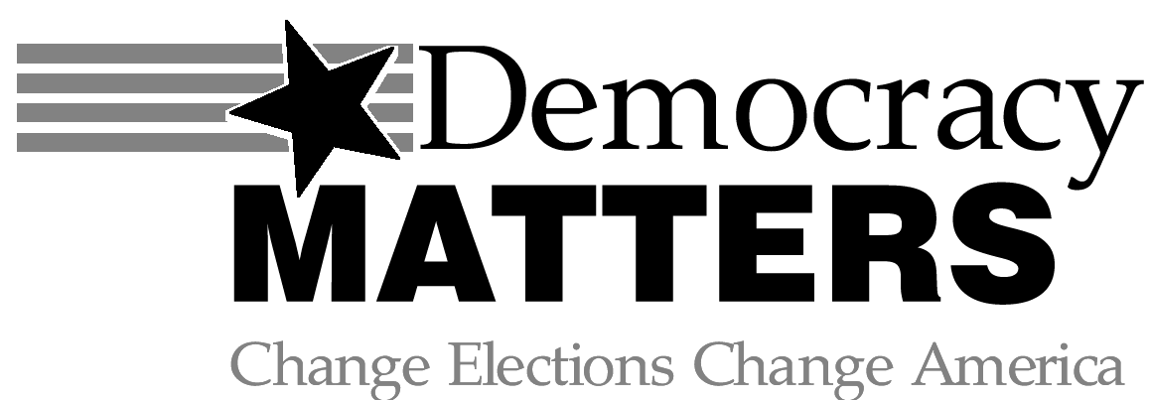
OPINIONS
Republican leaders have said they expect the bill to save $30 million by July 1st and $300 million over the next two years in order to combat part of the $3.6 billion budget shortfall. The only other option, Republicans say, is layoffs. Up to 6,000 people could lose their jobs if the measure does not pass and individuals do not take cuts.
Liberals say Wisconsin state employees cannot afford this bill and the elimination of collective-bargaining rights would set workers rights back decades. The bill also makes public workers responsible for half the cost of their pensions and around 13 percent of their health care costs. Republicans say this is modest in comparison to the responsibilities of workers in the private sector. Republicans also say the bill is long overdue as it increases worker’s rights by allowing them to choose to unionize or not.
Understandably, the unions do not like this idea as it may mean decreased participation in their programs and decreased mandatory revenue stream from automatically deducted dues. Union dues pay for immense campaign contributions and most of that money goes to Democrats. Unions have been lobbying the Democrats to stay out of congress and the Democrats have been listening. They even scoffed at the $100/day fine. Senator Chris Larson said none of them “even flinched.” The Democrats have been calling for a recall on the Republican senators.
Private sector employers are mostly in support of this bill as it may set a precedent to minimize collective bargaining and costs for their employees as well. Republicans have been bashed lately for accepting campaign contributions from corporations and individuals like the Koch brothers. Ironically, the pension plans for most Wisconsin state employees are partially invested in the Koch’s corporations. This means their pension plans are both supporting the Koch brothers’ “evil” corporations and reliant upon their success to pay for their retirement.
No matter which side of the issue you are on, you have to admit something needs to happen to decrease spending, worker’s rights need to be upheld and the importance of special interests like unions or corporations need to be weighed appropriately. Right now, the senators are mostly trash talking each other, something everyone can agree is neither productive nor professional. But, hey it’s just politics, right? It doesn’t actually affect you.

BRIEF BACKGROUND
Protesters have been gathered in Madison, Wisconsin since mid-February. They are protesting a bill strongly supported by Governor Scott Walker which would eliminate elements of collective bargaining for state employees and make union membership optional for employees. Currently, union membership is mandatory for any state employee and union dues and fees are taken out of their paycheck. Under the new bill, they would pay dues individually and vote more often to maintain membership. The Wisconsin state senate requires 20 members to hold a quorum for any spending bill. The 14 Democrats have boycotted the capital to prevent a vote, as there are only 19 Republicans in the state senate. Republicans were able to pass fines for the absentee senators of $100 a day to cover administrative costs and part of the salary paid to them by tax payers for each day they do not show up to work.

WHAT CAN YOU DO?

SUPPORT COLLECTIVE BARGAINING RIGHTS:
http://www.cwa-union.org/issues/entry/c/workers-rights/page/s/aflcio?source=aflcioweb

SUPPORT THE FREEDOM OF CHOICE:
http://www.americansforprosperity.org/walker/

DEMOCRACY MATTERS MEETINGS
WEDNESDAYS
6:30 PM
THE GUSTIE DEN

