Potty Politics
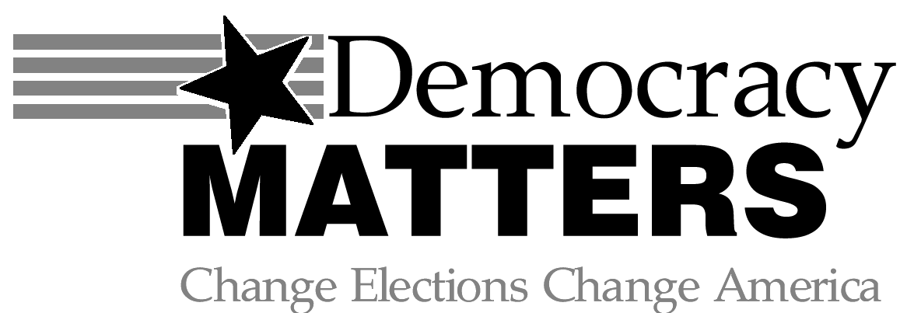
INTERNATIONAL PUBLIC HEALTH –HIV/AIDS NOVEMBER/DECEMBER 2010
THE PRESIDENT’S EMERGENCY PLAN FOR AIDS RELIEF (PEPFAR)
PROGRAM OVERVIEW
The United States Government is the single largest donor to HIV/AIDS relief projects. President Bush established PEPFAR in 2003 to disburse $15 billion over 5 years. He renewed, revised and expanded the program in 2008, providing $48 billion through 2013 for HIV/AIDS, Tuberculosis and Malaria. President Obama’s 2011 budget does not reflect the planned increases in funding. This could be catastrophic for the program as the expansions planned for 2011 are still underway. If the funding doesn’t catch up there will be a retroviral deficit that will cost some people their lives.

MORAL GUIDELINES
USAID money is disbursed directly to target governments with US directives and budget mandates. 6.7% of the funding supplied by PEPFAR has been specifically designated for A-B programs (Abstinence, Be Faithful). The efficacy of these programs has been challenged, but overall PEPFAR has been effective. In 2009, PEFAR was shown to have reduced the AIDS death rate in the 15 target countries by 10%. PEPFAR has a nonsupport policy for any governmental or NGO that does not explicitly oppose prostitution and sex trafficking. Now removed, the original charter refused to support any organization which performed or promoted abortion as a form of family planning. Needle exchange programs, which have been shown to be highly effective in reducing sharing and infection by IV drug users, are not highly supported.

LEADERSHIP
The projects are overseen by the United States Global AIDS Coordinator. The first coordinator, Randall L. Tobias was a former executive from the major pharmaceutical company, Eli Lilly. During Tobias’, short stay with the program, it was criticized for only supplying branded retrovirals over cheaper generic versions. In 2006, Tobias was replaced by Physician, Dr. Mark Dybul, who was asked to step down when President Obama took office. Some have speculated that this was in response to the mandated funding of abstinence programs.

Sources: The Avert Project, The Norwegian Institute for Urban and Regional Research, PEPFAR

“The global HIV/AIDS epidemic is an unprecedented crisis that requires an unprecedented response. In particular it requires solidarity -- between the healthy and the sick, between rich and poor, and above all, between richer and poorer nations. We have 30 million orphans already. How many more do we have to get, to wake up?” -Kofi Anon

Global AIDS Day is December First
Wear Red

W
THE GLOBAL HIV/AIDS EPIDEMIC
- 33.4 million people currently live with HIV/AIDS globally
- 2.7 million people were infected in 2008 alone. 1.9 million in Sub-Saharan Africa
- 2.0 million people died in 2008, and 25 million have died since 1981
- 14 million children have been orphaned because of AIDS, as of 2008.

Modern medicine may determine the available options, but modern politics will always determine funding. Tell your representatives that you want evidence- not opinion- based intervention in the HIV/AIDS epidemic. This debate actually is Life or Death.

DEMOCRACY MATTERS MEETINGS
MONDAYS 6:30-7:00 PM
IN THE GUSTIE DEN
New members are always welcome!

